Introduction to AEM & Runmodes
1. Define the priority when run mode are applied using options
sling.properties file --- 2nd
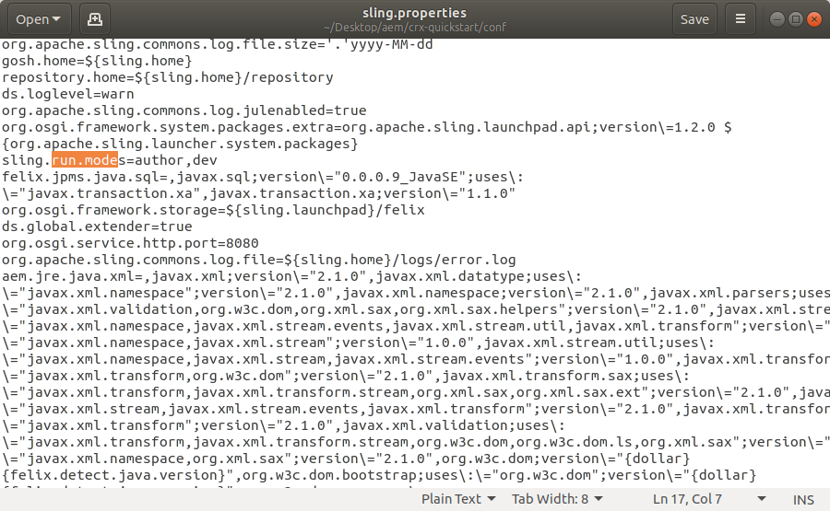
system properties (-D) --- 1st
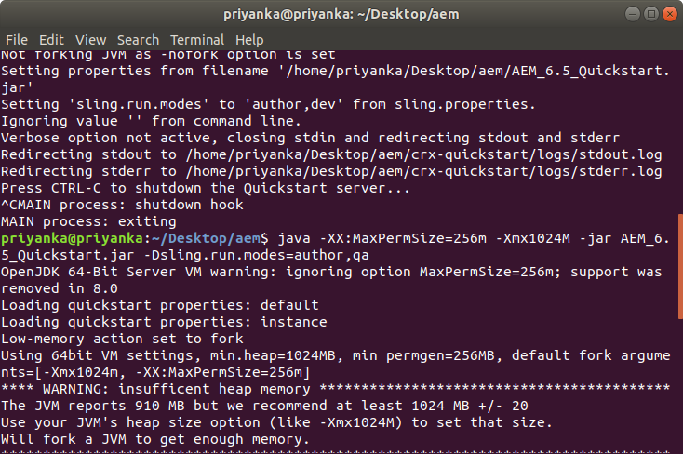
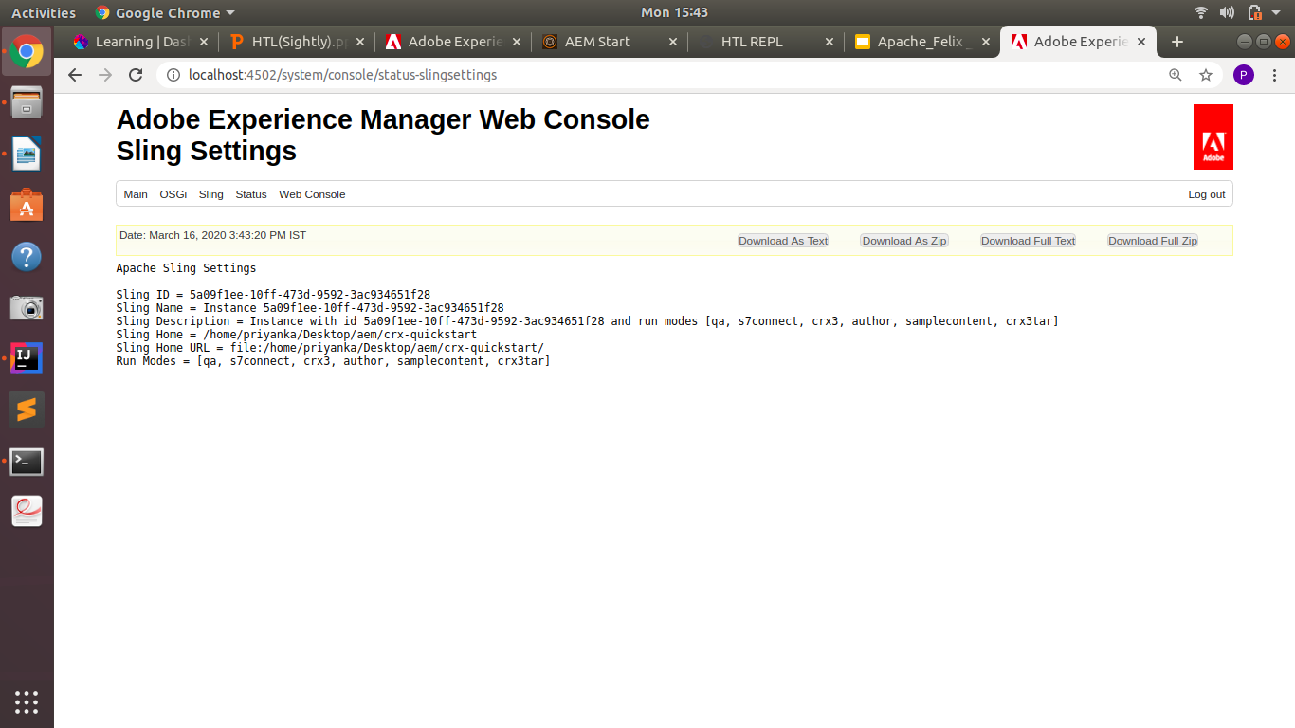

2. Creating a OSGi service which have two properties to configure. Define these configuration for run modes :
a. Dev
<?xml version="1.0" encoding="UTF-8"?>
<jcr:root xmlns:sling="http://sling.apache.org/jcr/sling/1.0" xmlns:jcr="http://www.jcp.org/jcr/1.0"
jcr:primaryType="sling:OsgiConfig"
blogCategory="technical"
rank="3"
/>

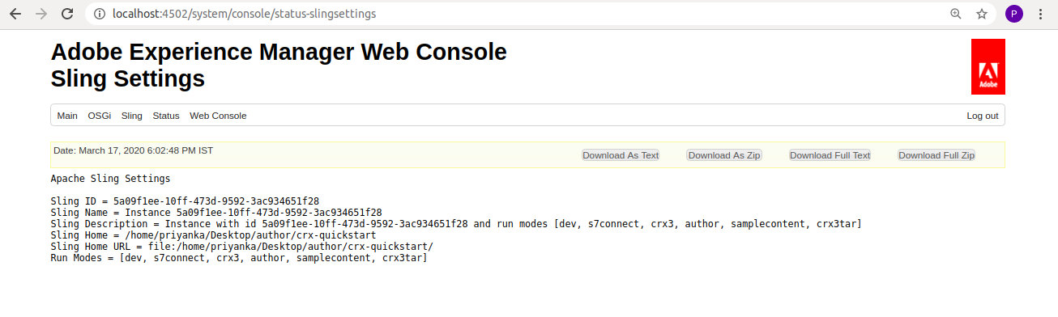

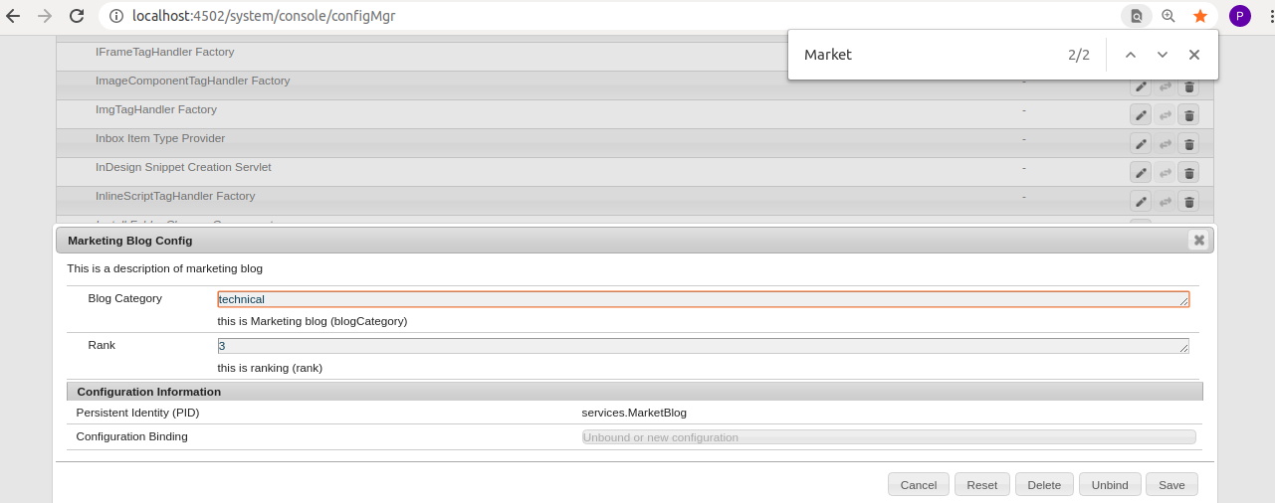
b. dev,pub
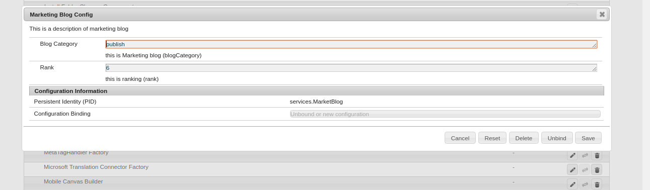
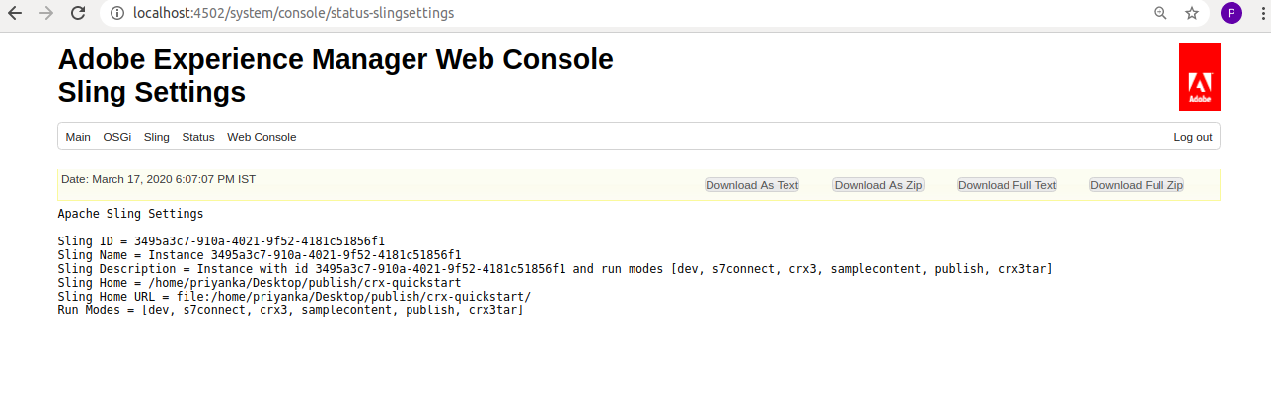

<?xml version="1.0" encoding="UTF-8"?>
<jcr:root xmlns:sling="http://sling.apache.org/jcr/sling/1.0" xmlns:jcr="http://www.jcp.org/jcr/1.0"
jcr:primaryType="sling:OsgiConfig"
blogCategory="publish"
rank="6"
/>

